1. Introduction

This section of the report will explain how the design and development of the interior will be accomplished. Considerations for the Interior are the ergonomics and the adjustability of functions therein.

1. Ergonomics

*Ergonomics* is important because it will allow for the best design for a comfortable drive for the commuter and increase the enjoyment of the drive. This section describes the components that have been developed to provide ergonomic comfort to the Vehicle’s drivers; that is, posture, and eye sight and reach.

* 1. Posture

How the driver sits while driving the vehicle is important to keep that driver within his/her own comfort level. An irritable drive due to lack of comfort could cause a dangerous driving experience because of lack of attentiveness to the road. Also, poor posture could lead to lower back injuries in cases of repetitive and long term exposure to that posture [1]. Maintaining *lumbar support* is crucial for the driver’s comfort.  Figure 1 shows areas of the *lumbar region* that need to be considered. To support the lumbar area the driver’s seat cushions are to be developed to provide recommended shapes and forms to fit the driver’s own distinct shape. Table 1 lists recommended values. The seat cushion should have a *prominence* within 15mm to 20mm. This will allow the cushion to form within the area and shape of one’s lower back providing support to the lower back region. The curvature of the cushion prominence will have a radius of 300mm to mimic the curvature of a human’s spine curvature. These recommendations will not be adjustable and so will be fixed, as shown in Table 1, and so must be able to meet the average shape of the average human.

Figure 14: Schematic Illustration of Lumbar Support Recommendations (dimensions in mm). [2]

Another crucial location for considering a comfortable drive is the location of the *H-point*. How the driver sits in relation to the H-point will determine how he orients his lower back with the seat and reach of his legs. The H-point is used to determine where in the seat the driver’s buttocks is placed. This allows for accurate mapping of the seat cushion positions which placed poorly can lead to driver discomfort; see Figure 1 and Table 1.

|  |  |
| --- | --- |
| Parameter | Recommendation |
| Lumbar Support (Fixed) |  |
| * Vertical Design | Locate apex 200–250 mm above depressed seat surface, or  105–155 mm above H-point along back line. Mean preferred height is 150 mm above the H-point. |
| * Prominence | Support should protrude 15 to 20 mm in front of backrest  plane (see Figure 1), yielding a lumbar support prominence measure of 15 to 20 mm. |
| * Radius | The 20-mm support should have a depressed-contour,  convex radius of about 300 mm. |
| * Sacral Relief | Adequate relief should be provided below the lumbar support for the sitter’s buttocks. |
| Lumbar Support (Adjustable) |  |
| * Vertical position | Apex should be adjustable between 100 and 200 mm above the H-point along back line. |
| * Prominence | Prominence should be adjustable between 0 and 30 mm. |
| * Radius | Radius should be adjustable between 250 and 400 mm. If only a prominence adjustment is provided, higher |
| Knee Angle | Included angle between leg and thigh should be less than 135°. Mean preferred angle is 122 degrees. |
| Trunk/Thigh Angle | Angle formed by the knee, hip, and shoulder joints should be larger than 90°. Mean preferred angle is about 105 |
| Back Angle | Angle relative to the vertical of line from hip joint to shoulder joint should be between 10–30°. Mean preferred angle is 28 degrees. Mean preferred angle of line from hip to eye is about 10 degrees. |

Table 3: Support Parameters Recommendations. [2]

However, it should be noted that seat cushions help support posture, but poor posture by the driver is not controlled by the addition or removal of seat cushion supports. If the driver does not make full use or sits poorly for any reason, the benefits of these supports will be nil. As such these values are recommendations and not binding to the driver’s posture in anyway.

* 1. Reach and Eye Sight

Being able to reach the pedals comfortably without straining oneself ensures a safe enjoyable drive. As stated above the H-point determines how much length of the leg is available to reach the pedals based on position in the seat itself. Reaching with one’s feet is not the only concern. Being able to reach the steering wheel without strain is important for the comfort of the driver and his control over the Vehicle. However, the need to reach other accessories within the interior means that they should be located within eye sight. *Peripheral vision* is an important factor for reaching other accessories without taking one’s eyes off the road. Checking mirrors should also be included within easy movement of the head to ensure accurate knowledge of upcoming road conditions and surroundings.

1. Adjustability

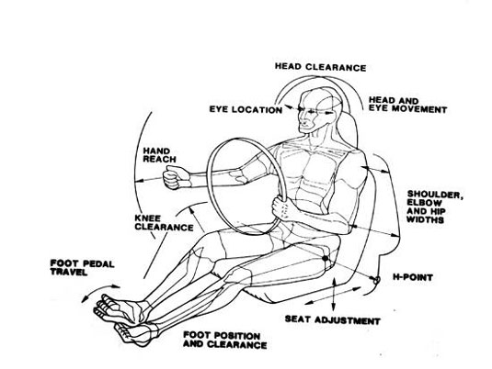Not every driver of our Vehicle will have the same shape, size, and unique tastes to comfort. Figure 2 illustrates possible locations for adjustable functions within the interior of the Vehicle. However, due to limitations of space and quantity of functions in the interior, not every possibility shown in Figure 2 will be applicable. In the preceding section reach was talked about as an important criterion for control of the Vehicle and comfort. Now, reach will be further developed to include adjustable parameters.

Figure 15: Key Locations for Comfort and Adjustability [3]

The Human body can be modelled as a system of linkages [2, p. 47] as shown in Figure 3. This allows for the mapping of the human body in relation to a seated posture. The most important angles for comfort are the back, trunk/thigh, and knee angles [2, p.48]. Knowing where the most important locations are, the design of the seat can be allowed to adjust at these locations for the driver chosen comfort. Recommended functions to be allowed to adjust and move are the seat position in relation to the pedals and the seat backrest in relation to a 90 degree angle. Allowing the seat to be adjustable such that it can be moved further away or closer to the pedals depending on the user will change the knee angle. This will allow the driver to reach the pedals more comfortably, without strain, or in the rare cases without the aid of wooden blocks attached to their feet. As our Vehicle is primarily operated with pedal-power, being able to reach the pedals is of critical importance. *Seat translations* should be of the magnitude of 150mm to 200mm [2, p.52]. This will allow the driver to maintain suggested knee angle orientations shown in Table 1.

Figure 16: Seated Posture Angles. A: Back, B: Trunk/Thigh, C: Knee, D: Ankle, E: Upper arm, F; Elbow. [2]

The location of the seat backrest is the other adjustable function chosen to optimize the interior and suit individual comfort. The adjustment of the back rest affects the back angle, one of the critical angles of the seated posture and also the reach of the arms. Allowing for the back rest to adjust up to 20 degrees [2, p.53] is crucial for driver comfort and for reaching the steering wheel of the Vehicle. With the knee angle and back angle being adjustable the back angle will be adjusted coincidentally because of the model of human linkages shown in Figure 3. This will ensure seated posture comfort at the H-Point location.